**QUESTIONS**

**Tutorial 1**

1. Software crisis refers to the challenge of creating practical, effective computer applications in the allotted amount of time. The software crisis resulted from the complexity of the problems that could not be solved and the tremendous advancements in computing power. Numerous software issues emerged as a result of the inadequacy of current solutions as program complexity increased.
2. Planning, Analysis, Design, Implementation, and Maintenance are the five major phases in the Systems Development Life Cycle. They are defined as follows:

a. Planning refers to the process of developing goals for the system and defining necessary steps to achieve those goals in the required time.

b. Analysis refers to the process of examining requirements for the system in order to better understand it.

c. Design is simply the process of planning how the system will work and function.

d. Implementation is simply the act of executing the defined plan for the system.

e. Maintenance is simply the process of keeping regular system updates for better performance.

1. Program Data Independence is backed up by a database system wherein its administrators have the ability to change the schema without affecting the entire schema. File-based information systems fail to support it because they do not have any independent programs and in order to change the program, the data also have to be changed. In addition, they are mostly obsolete and difficult to maintain.
2. Database Management System is a software package that can be bought from companies such as Oracle and Microsoft. It is fundamentally a mechanism for keeping electronic data. Users of the system are provided with the ability to carry out various types of operations on such a system for either manipulating the database's data or managing the database structure itself.

**Tutorial 2**

1. The major concerns that are involved in the planning phase of SDLC are Project Selection, Feasibility Analysis, SDLC Variant Selection, Project Plan, Project Staffing, Project Management, and Risk Management Plan. They are described as follows:

a. Project Selection refers to the identification of the size, cost , purpose, time-frame, risk, scope and economic value of the project.

b. Feasibility Analysis refers to the evaluation of the project concerning the likelihood of it being successful.

c. SDLC Variant Selection is simply identifying the proper variant for a project. Variants include waterfall, parallel, v-model, iterative, system prototyping, throwaway prototyping, and agile development. This will give structure to the project from start to finish.

d. Project Plan determines all the work in a certain project. This includes the defining of the project mission and vision, enumerating all the proposed tasks and how to successfully achieve the set goals, identifying the persons involved in the assigned tasks, pointing out the needed resources and budgets, and setting the time schedules so that the project will be done on time.

e. Project Staffing is assigning tasks to certain individuals in a team to avoid conflict and for motivation purposes.

f. Project Management refers to bringing the team members into a harmonious relationship by coordinating and managing them efficiently to eliminate issues that may arise. Coordination includes using CASE tools, standards, and documentation while Management involves paying attention to the system size, time, and cost of the project.

g. Risk Management Plan includes identifying, analyzing, evaluating, treating, and monitoring the risks that are involved in the project.

1. The advantages of using Database Management System are:

a. Users can easily open, manage, and share the data in the database as long as they are authorised to do so.

b. There is no duplicate data and any change in the database can be seen straight away.

c. Data is accurate at all times.

d. Data is secure as authorised persons are only allowed to open and manage the database.

e. There is no conflict in the requirements

f. New registrations are easier to manage and develop

The disadvantages of using Database Management System are:

a. Expensive

b. Hardware is pricey

c. Conversion costs tends to increase

d. The system may be vulnerable to attacks as data is centralized

e. Complex system

f. Size of the system

1. The ANSI-SPARC (American National Standards Institute Standards Planning and Requirements Committee) 3 Level Architecture’s goal is to keep the independence of each viewer so that if there are modifications in the schema, that will not have any effects to the other users.

It has three levels, namely - External Level, Conceptual Level, and Internal Level.

1. External Level or Users View is a level wherein a user can only access information that is only relevant to a particular user. This means that irrelevant data are excluded.
2. Conceptual Level defines what data are inside the database and how the data are interrelated with each other. And,
3. Internal Level specifies how the database is physically stored in the database system and on the computer.

4. The capability to make changes to the conceptual schema without changing external views or programs is Logical Data Independence. Whereas, the capability to absorb any changes in the physical or internal storage structures by the conceptual schema is known as Logical Data Independence.

The three levels in ANSI-SPARC 3 level architecture are as follows

1. Internal level
2. Conceptual level
3. External level.

It supports logical data independence by mapping the external and conceptual levels. And also, supports physical data independence by mapping the internal and conceptual levels.

1. Create a subject table in SQL and 6. Drop the table

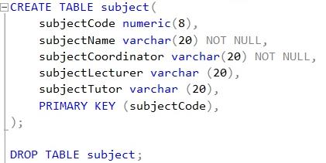

**Tutorial 3**

1. Business requirements are necessary qualifications or criteria implemented by a company in accordance to the business rules.

Business rules are governing instructions set by a company regarding business activities such as business operations and constraints.

2. a) Interview is simply asking questions to one or more persons to get certain answers.

b) JAD (Joint Application Development) Session is a group meeting of specialists within the company to discuss, review, and improve business requirements for the company.

c) Questionnaire is a list of questions and answer choices in printed form used for statistical studies.

d) Document Analysis is a type of research wherein documents are examined and explained thoroughly using various methods such as stakeholder interviews, survey, administrative data review and document review.

3. a) Candidate key is a non-null value and a unique field in a relational database. It can also become a primary key. There can be multiple candidate keys.

On the other hand, the primary key is a non-null value and a unique field that identifies a record in a relational database. Only one candidate key can qualify as a primary key which means that there can be only one primary key.

b) StudentID, FirstName, and LastName are Candidate keys while the StudentID is the primary key.

4.

|  |  |
| --- | --- |
| **E-R MODEL** | **RELATIONAL MODEL** |
| It is the collection of entities and relations between the entities. | It is the collection of tables and the relation between the tables. |
| In E-R model data can be Entity set, Relationship set and Attribute. | In the Relational Model data in a table are Domain, Attributes, Tuples. |
| It is easier to understand the relation between different entities. | It is not easy to derive a relation from tables in the Relational Model. |

5. Decrease the Hilton room price and 6. Select the room which price more than 100

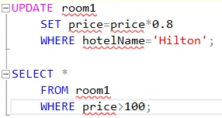

**Tutorial 4**

1. Events are simply occurrences or objects caused by an actor resulting for an activity to happen while use cases are activities that define the interaction between two or more entities called actors and are presented as plain text or as a diagram. There are two types of events: primary events and secondary events. Primary events cause use cases to occur while secondary events become a part of the use case dialogue. One primary event can have multiple secondary events.
2. Preconditions is a state of the system wherein the tests must be proven true before the use case executes the function.

Example: To check if a student is enrolled in a unit.

Postconditions is the state of a system in indicating the objects that the use case should prove true before ending the function.

Example: Displaying the grades of a student.

1. (Π type, price (room))hotelNo = ‘Hilton’ and price < 200

Natural join:

|  |  |  |
| --- | --- | --- |
| staffID | salary | name |
| 12345 | 80,000 | James |
| 54321 | 100,000 | Gaga |

Natural left outer join:

|  |  |  |
| --- | --- | --- |
| staffID | salary | name |
| 12345 | 80,000 | James |
| 54321 | 100,000 | Gaga |
| 67890 | 30000 |  |

Natural right outer join:

|  |  |  |
| --- | --- | --- |
| staffID | salary | name |
| 12345 | 80,000 | James |
| 54321 | 100,000 | Gaga |
| 09876 |  | Super |

Natural full outer join:

|  |  |  |
| --- | --- | --- |
| staffID | salary | name |
| 12345 | 80,000 | James |
| 54321 | 100,000 | Gaga |
| 67890 |  | 30000 |
| 09876 | Super |  |

1. Select all rooms in Home hotel with value of price < 150 in order by roomNo and types, also 6. add columns view and floor to the room table.

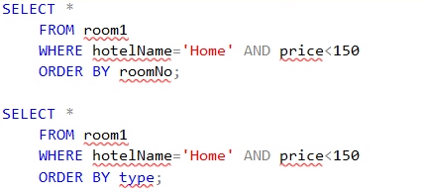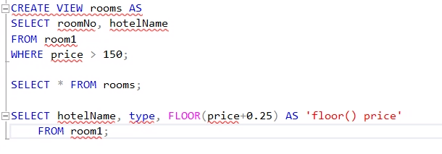

**Tutorial 5**

1. Context Diagram is used to describe and explain the system boundaries wherein the entire system acts as a single process.

1. Level 0 Diagram displays all the high-level processes and how they interact with external entities.
2. Level 1 Diagram shows in a detailed manner how the main processes are broken down into sub-processes.
3. Level 2 Diagram is more detailed compared to Level 1 Diagram as some processes are broken down into more specific sub-processes.

Level-n Data Flow Diagrams are dependent on Level n-1 Data Flow Diagrams.

2. Wrong use of symbols. To avoid this, a symbol should be used correctly so that the data flow diagram will not affect the process.

1. Having too many processes as it is confusing to the readers. Group together the processes that are related with each other to create a subsystem.
2. Data stores and external entities are connected with each other. They should only be connected to a process not with each other.
3. Illegal data flows. To avoid this, a data flow diagram must start and end with a processing step.

3. A view in a relational model is a virtual table computed from the data in a database while an actual relation in a relational database is a set of tuples stored in multiple relations or tables divided into rows and columns. Furthermore, an actual relation or table consists of values while a view is a query of base relations but does not have any data.

4. Referential Integrity is a set of constraints applied using foreign keys which prevents entering a row in a child table (table having foreign key) for which there is no corresponding row in the parent table.

Example:

1. This constraint does not allow an INSERT or UPDATE statement to change the value of room_id in the child table if the value of room_id is not present in the Room table.
2. It also does not allow to delete a row from the parent table if the child table uses the value of the parent table of that row.

5. Create a table unit with required attributes.

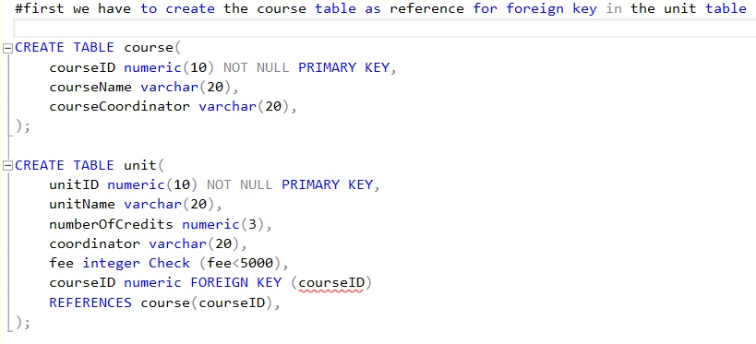

**Tutorial 6**

1. Process modeling is a method in the analysis phase wherein information is gathered, organized and recorded using the system’s rules, procedure and logic to be executed by the system’s processes. While data modeling is a technique in the analysis phase wherein data are described in order to show how the requirements stated by the end-user should be met.

2. Weak entity example: Preference

Owner of Preference is Staff

3. Example of Associative Entity: Enrolment

Our many-to-many relationship would be Student and Course. And if we will associate Enrolment with the Lecturer, then the Enrolment will be considered as an associative entity.

4. Example of Specialization/Generalization:

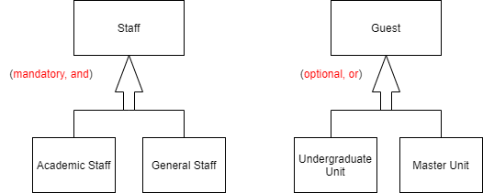

5. Select some rooms booked by some guests from Mars. Also, 6. guest who has booked at least two rooms in the same hotel

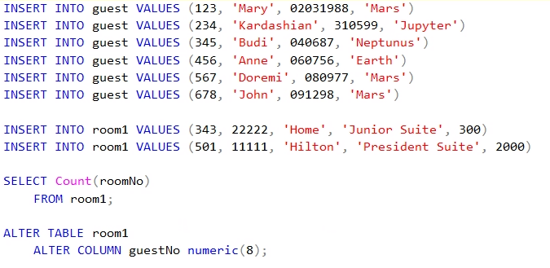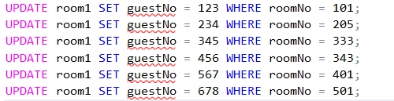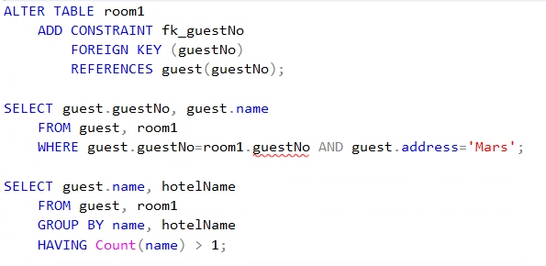

**Tutorial 7**

1. The main strategies for system acquisition are custom development, packaged system and outsourcing. The considerations to choose each of them are business need, in-house experience, project skills, project management and time frame.

2. The main types for system architectures are client-server architecture, client-server tires, server-based architectures, and client-based architectures. It is usually chosen depending on the existing infrastructure in the organization and corporate standards.

3. Attributes to relationship in an ERD.

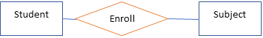

4. To address the issue of unclear business rules related to ERD is by refining the nonfunctional requirements in detail, such as operational requirements, performance requirements, security requirements, and cultural and political requirements.

5. Student and staff’s names and emails in unit 300977 and 6. Guests who book more than 3 rooms 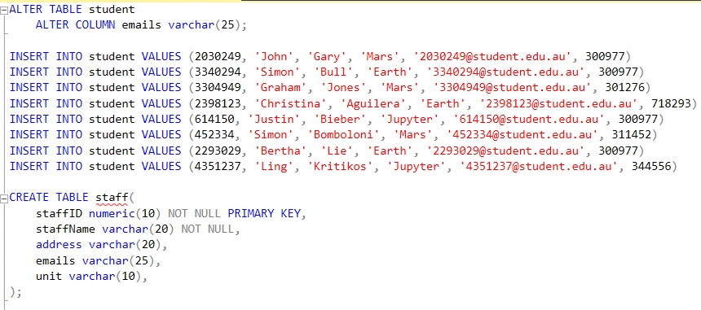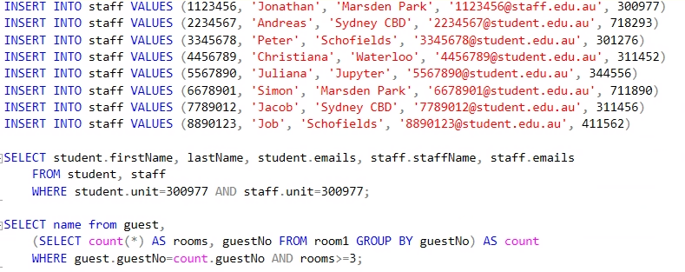

**PRACTICES**

**Tutorial 1**

**(no questions in tutorial 1)**

**Tutorial 2**

**I. Final Project Planning**

**a)** Our objective why we chose to develop a Database System for the Master Course of ICT is because we would like to create a centralized database that will store, track, maintain, and retrieve information of ICT students, grades of students, units being offered, and lecturers. This database system will help the managing team’s work a lot easier as it will simplify their job.

**b)** Yes, this project is feasible because the likelihood of this project’s objective to be achieved in the following aspects are high:

## **Technical Feasibility:**

This project is technically feasible as the system will be developed using a database system which we know how to use and we don’t need to learn any new technical skills.

## **Economic Feasibility:**

This project is economically feasible since the development of the system requires a database management tool which is available for free. And, we have plenty of time to complete this project as we are a team of two people.

## **Organizational Feasibility:**

## Our system provides services which are developed to be flexible and can be easily expanded in the future. The proposed system will have high usage among the students and university staff.

## **Operational Feasibility:**

## The system will be developed using a free and open-source database and there are many free tools available to interact with the database. So very less economic and time resources will be consumed for the deploying and operating of the proposed system.

**c)** The variant of SDLC that we will use in this project is Agile Development as it will allow us to adjust priorities as the project progresses resulting in improved product quality delivery.

**d) Project plan**

1. **Project Scope**

**1.1 Scope Statement**

Western Sydney University wants us to develop a Database System for the Master Course of ICT. The database system will be released on October 19, 2020. The project will not cost anything as we are going to use MySQL and MySQL Workbench tool which is completely free.

**1.2 Objectives**

1. Create and develop a fully operational database system based on the features defined in section 1.3.
2. Make certain that the contents of the database should be very secure.
3. Release the database system on Week 14 (October 19, 2020).

**1.3 System Features**

In the scope of this project, the following features per user are included:

User: Features:

a. Managing Staff - Manage Students, Lecturers, and Units

- Manage Student Result

- Manage School Notification

- Define Unit Schedules and Units for Students and Lecturers

- Generate Fee Structure for University

- Generate Reports

b. Lecturers - Manage Students Assignment

- Assign Assignment

- Manage Student Grades

- Generate Remarks on Student Grades

- Generate Student Attendance

c. Students - Submit Assignments

- View Unit Schedules

- View Grades

- View Remarks

1. **Gantt Chart**

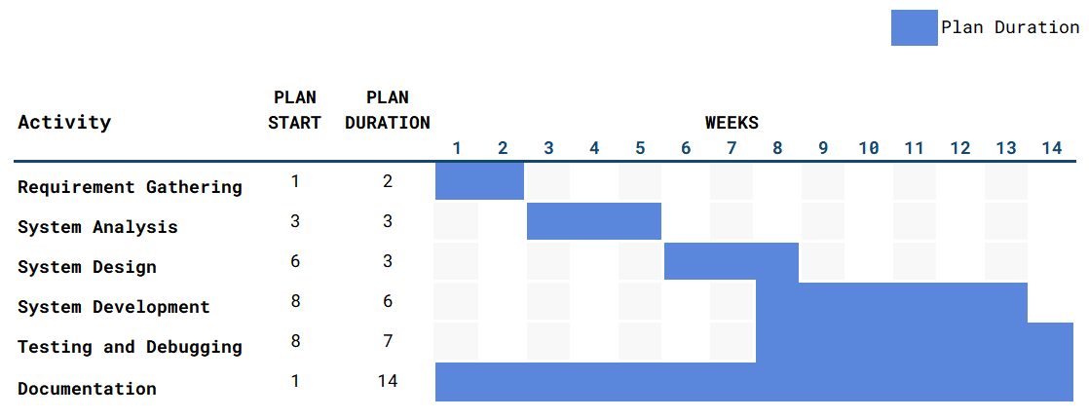

**3.Stakeholder Analysis**

The Project Team is identified as the internal stakeholders while the users (managing staff, teaching staff, and students) are the external stakeholders who contribute to this database system project.

**e)** Our group consists of two members Patricia Ann La Madrid and Shijan Kumar Shrestha who are enrolled in the unit Systems Analysis and Database Management at Western Sydney University.

**f)** **Communication Plan:**

- Project meetings are held in Zoom and the documentation is done in google docs.

**g) Risk Management Plan:**

It is critical to eliminate risks from the start to ensure that the database system project will be completed before the deadline. The following potential risks were identified by the team while developing the project:

## **Time Risk:**

Since the course requires us to finish the project within the spring semester, no extensions are allowed. This also means that any feature or improvements not implemented within the deadline may not go into the final product. Due to the time constraint, time must be treated as a resource and implementation of any feature or improvement needs to be calculated against the time available.

## **Resource Risk:**

This system doesn't require a huge resource for development. All the required resources are easily available, so there will be no resource risk.

## **Risk Management:**

## For the solution to the time risk, the team will work as the outline plan in a very strict manner. Also, as the process model being agile development, the database system will be developed in manageable parts.

II. SQL – connected to Microsoft SQL Server Management

III. SQL – Table Creation and Deletion

**Tutorial 3**

**I. Requirement analysis.**

**a) Predefined Queries**

1. How many students are enrolled in a particular unit?

2. Who is the lecturer of a particular unit?

3. What is the average score of the students enrolled in a particular unit?

4. List all units offered on Monday.

5. List all students who get a D or HD grade in a particular unit.

6. List all students and units such that the students have failed the units.

7. List the lecturers who teach a particular student on Monday.

8. What are the units completed by a particular student?

9. What are the units failed by a particular student?

10. List all the lecturers who teach a particular unit.

**b) Interview**

Question by Patricia: What do you think about the business rules for our system?

Shijan’s Answer: 1. To use the system the user must be registered in the system.

2. Students cannot select the units they are already registered in.

Question by Shijan: What could be the business requirements for our system?

Patricia’s Answer: 1. Validating the users while they log into the system.

2. For every unit a student selects there should be validation that checks if the student is already registered in that particular unit.

**c) JAD Session**

We conducted a JAD session which included following steps:

1. Defining the objectives for JAD session:

i. Session objectives:

To find more business rules and business requirements for our system.

ii. Session deliverables:

New business rules and business requirements.

iii. Participant list:

Project members and the other stakeholders.

2. Preparing for the session.

i. We conducted a pre-session research.

ii. We created a session agenda.

iii. We arranged session logistics.

iv. We prepared the participants for the session.

3. Conducting the JAD session.

We started the meeting on time and all the participants were asked to generate new ideas to explore potential opportunities.

4. Producing the documents

We completed and organized the final document for easy use by project members.

**d) Questionnaire**

1. The development of this MICT system would be very helpful for the student, teachers and managing staff.
2. Strongly Agree
3. Agree
4. Uncertain
5. Disagree
6. Strongly Disagree
7. It would be helpful if you get an email about the various events and announcements in the system.
   1. Strongly Agree
   2. Agree
   3. Uncertain
   4. Disagree
   5. Strongly Disagree

**Tutorial 4**

**I.**

a) Student Use Case:

|  |  |
| --- | --- |
| **Title:** | Register for units |
| **Description:** | Actor wants to register for a unit provided for the current semester. |
| **Actor:** | Student |
| **Pre-Condition:** | Actor must log in to the system before this use case begins. |
| **Flow of events:** | 1. The System shows the list of units available for the current semester.  **Business rule: Students cannot select the units they are already registered in.**  2. The actor selects the units from the list of available offerings.  3. The system displays the unit schedule available for the selected units.  4. The actor selects the schedule from the list of available schedules. The actor can also change the schedules later up to for a fixed duration.  5. The units are saved in the system. |
| **Frequency of Use:** | This use case applies every time an actor wants to register for a unit. |
| **Post Condition:** | The student is registered in a unit and can view details and the schedule. |
| **Alternative Flow:** | If all the units are full, the actor cannot register for units and the use case ends. |

|  |  |
| --- | --- |
| **Title:** | Submit Assignment |
| **Description:** | Actor wants to submit an assignment for a unit. |
| **Actor:** | Student |
| **Pre-Condition:** | Actor must log in to the system before this use case begins. |
| **Flow of events:** | 1. The system shows the list of units that the actor is enrolled in.  2. The actor selects the units for which he/she wants to submit the assignment.  3. The system provides the list of options to the user.  4. The actor selects the option to submit the assignment.  5. The system displays the field to upload the files.  6. The actor uploads the files in the system.  7. The submitted assignments are saved in the system. |
| **Frequency of Use:** | This use case applies every time an actor wants to submit an assignment. |
| **Alternative Flow:** | If the assignment submission is closed, the actor cannot submit the assignment and the use case ends. |

b) Teaching Staff:

|  |  |
| --- | --- |
| **Title:** | Submit Grades |
| **Description:** | Actor wants to submit grades to the students |
| **Actor:** | Teaching Staff |
| **Preconditions:** | The actor must log in to the system. |
| **Flow of events:** | 1. The system displays the list of units taught by the actor.  2. The actor selects the unit.  3. The system displays the list of all the students enrolled in the unit.  4. The actor enters the grade for each student in the list. The actor can also change the grades later.  5. The grades are saved in the system. |
| **Frequency of Use:** | This use case applies every time an actor wants to submit grades. |
| **Alternative Flow:** | If the actor does not teach any units, the use case ends. |

c) Managing Staff:

|  |  |
| --- | --- |
| **Title:** | Verify Student Fee Payment. |
| **Description:** | Actor wants to check if the student has paid the fee. |
| **Actor:** | Managing Staff |
| **Pre-Condition:** | Actor must log in to the system before this use case begins. |
| **Flow of events:** | 1. The system shows the list of units available for the current semester.  2. The actor selects the units from the list.  3. The system displays the list of students registered in the selected unit.  4. The actor checks all the students who have or have not paid the dues. |
| **Frequency of Use:** | This use case applies every time an actor wants to check student fee payment. |
| **Post-Condition:** | The actor gets the list of students who has not paid their dues and can notify the students to pay their fee. |
| **Alternative Flow:** | If no students are enrolled in the selected unit, the use case ends. |

**Tutorial 5**

**I.**

**a) student**

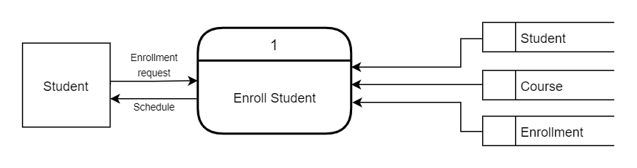

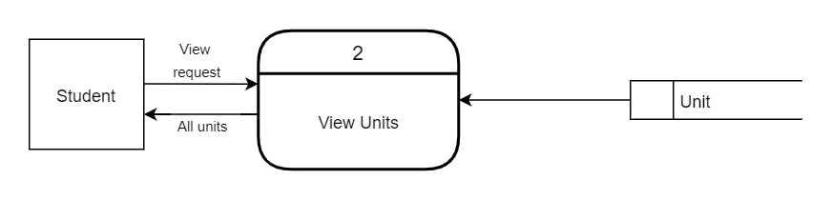

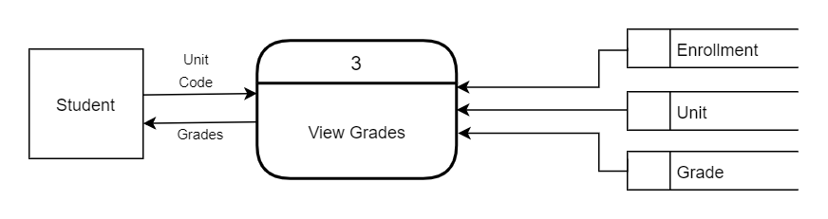

**b) teaching staff**

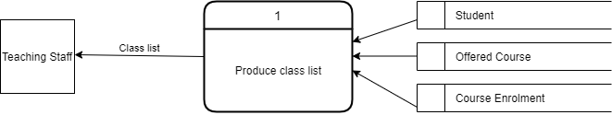

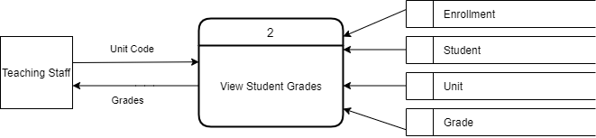

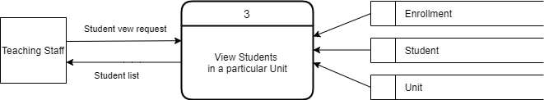

**c) managing staff**

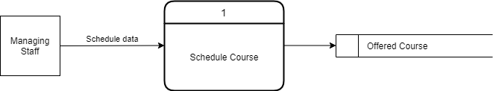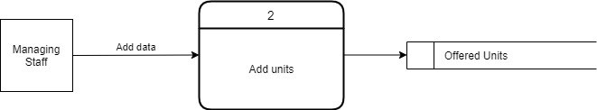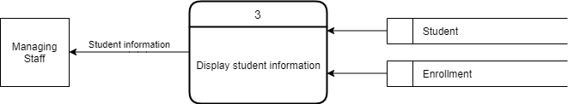

**Tutorial 6**

**I.**

1. **Summary**

In order to develop a Database System for the Master Course of ICT, the team will create a centralized database that will store, track, maintain, and retrieve information of ICT students, grades, units being offered, and lecturers. The database system will be released in October 2020. This will help the managing team’s work as it will simplify their job. This project plan gives a brief statement of how the team aims to deliver the fully operational database system within the given time-frame.

This project plan includes the project scope that has been defined based on the objectives. Gantt Chart is used to show the project into six phases. There is a system analysis phase to identify the business rules and requirements. The system design phase shows the use cases of different users.

Due to time constraint, it is critical to address and eliminate foreseeable risks from the start to ensure that the database system project will be completed before the deadline.

1. **System request**

This project involves the creation and development of a database system that will provide required information to the system users about the MICT course. The users of this system are students, teaching staff and managing staff. The administrator controls the database and can alter the contents of the database, while the users can read the data and information provided by the database.

This document has been created to outline how the team plans to design and develop the database system for the Master Course of ICT. This report consists of the Work Plan, Risk Analysis, Feasibility Analysis, Use Cases and Data Flow Diagrams.

The reason why we decided to create a database system for the Master Course of Information and Communications Technology is because database systems are crucial for educational organizations as it stores all the important records about the school including staff and students. This will not only help the students and lecturers but will simplify the work of the managing team.

1. **Work plan **
2. **Feasibility analysis**

This project is feasible because the likelihood of this project’s objective to be achieved in the following aspects are high:

## Technical Feasibility:

This project is technically feasible as developing a Database system using MSSQL and mylittleadmin tool which is provided by the university.

## Economic Feasibility:

This project is economically feasible since the development of the system requires a database management tool which is provided to us for free. And, we have plenty of time to complete this project as we are a team of two people.

## Organizational Feasibility:

## The services our system provides are designed to be flexible and expandable in the near future. Our proposed system will have its high usage among the students and university staff.

* Operational Feasibility:

The system will be developed using a database system which is a free and open-source software and there are many free tools available to interact with the database. So the economic and time resource will not be consumed much for the deployment and operation of the proposed system.

1. **Requirements definition**

**Functional requirements**

* Since the project is fully dependent on the database, the contents of the database should be very secure.
* The user is capable of accessing the data and the admin only can alter the database.
* Authentication of the user must be done every time they try to login to the system.
* The database system should be capable of generating reports as desired by the university staff and students.

**Non-functional requirements**

* The system should maintain efficiency in terms of processing speed. The system should be able to response to the request of the user as soon as possible
* It should not be of large size and the content in the database should be easily accessible.
* Maintenance process must be simple and easy if any error or problem occurs in future.

**Business Rules**

1. To use the system the user must be registered in the system.

2. Students cannot select the units they are already registered in.

**Business Requirements**

1. Validating the users while they log into the system.

2. For every unit a student selects there should be validation that checks if the student is already registered in that particular unit.

1. a) Student:

|  |  |
| --- | --- |
| **Title:** | Register for units |
| **Description:** | Actor wants to register for a unit provided for the current semester. |
| **Actor:** | Student |
| **Pre-Condition:** | Actor must log in to the system before this use case begins. |
| **Flow of events:** | 1. The System shows the list of units available for the current semester.  **Business rule: Students cannot select the units they are already registered in.**  2. The actor selects the units from the list of available offerings.  3. The system displays the unit schedule available for the selected units.  4. The actor selects the schedule from the list of available schedules. The actor can also change the schedules later up to for a fixed duration.  5. The units are saved in the system. |
| **Frequency of Use:** | This use case applies every time an actor wants to register for a unit. |
| **Post Condition:** | The student is registered in a unit and can view details and the schedule. |
| **Alternative Flow:** | If all the units are full, the actor cannot register for units and the use case ends. |

|  |  |
| --- | --- |
| **Title:** | Submit Assignment |
| **Description:** | Actor wants to submit an assignment for a unit. |
| **Actor:** | Student |
| **Pre-Condition:** | Actor must log in to the system before this use case begins. |
| **Flow of events:** | 1. The system shows the list of units that the actor is enrolled in.  2. The actor selects the units for which he/she wants to submit the assignment.  3. The system provides the list of options to the user.  4. The actor selects the option to submit the assignment.  5. The system displays the field to upload the files.  6. The actor uploads the files in the system.  7. The submitted assignments are saved in the system. |
| **Frequency of Use:** | This use case applies every time an actor wants to submit an assignment. |
| **Alternative Flow:** | If the assignment submission is closed, the actor cannot submit the assignment and the use case ends. |

b) Teaching Staff:

|  |  |
| --- | --- |
| **Title:** | Submit Grades |
| **Description:** | Actor wants to submit grades to the students |
| **Actor:** | Teaching Staff |
| **Preconditions:** | The actor must log in to the system. |
| **Flow of events:** | 1. The system displays the list of units taught by the actor.  2. The actor selects the unit.  3. The system displays the list of all the students enrolled in the unit.  4. The actor enters the grade for each student in the list. The actor can also change the grades later.  5. The grades are saved in the system. |
| **Frequency of Use:** | This use case applies every time an actor wants to submit grades. |
| **Alternative Flow:** | If the actor does not teach any units, the use case ends. |

c) Managing Staff:

|  |  |
| --- | --- |
| **Title:** | Verify Student fee payment. |
| **Description:** | Actor wants to check if the student has paid the fee. |
| **Actor:** | Managing Staff |
| **Pre-Condition:** | Actor must log in to the system before this use case begins. |
| **Flow of events:** | 1. The system shows the list of units available for the current semester.  2. The actor selects the units from the list.  3. The system displays the list of students registered in the selected unit.  4. The actor checks all the students who have or have not paid the dues. |
| **Frequency of Use:** | This use case applies every time an actor wants to check student fee payment. |
| **Post-Condition:** | The actor gets the list of students who has not paid their dues and can notify the students to pay their fee. |
| **Alternative Flow:** | If no students are enrolled in the selected unit, the use case ends. |

**a. Student**

1. Enroll in a unit



2. View Unit details



3. View grades



**b. teaching staff**

1. Produce class list



2. View student grades



3. View students in a particular unit



**c. managing staff**

1. Schedule Course



2. Add units



3. Display student information



**Tutorial 7**

**SAD Entity Relationship Diagram**

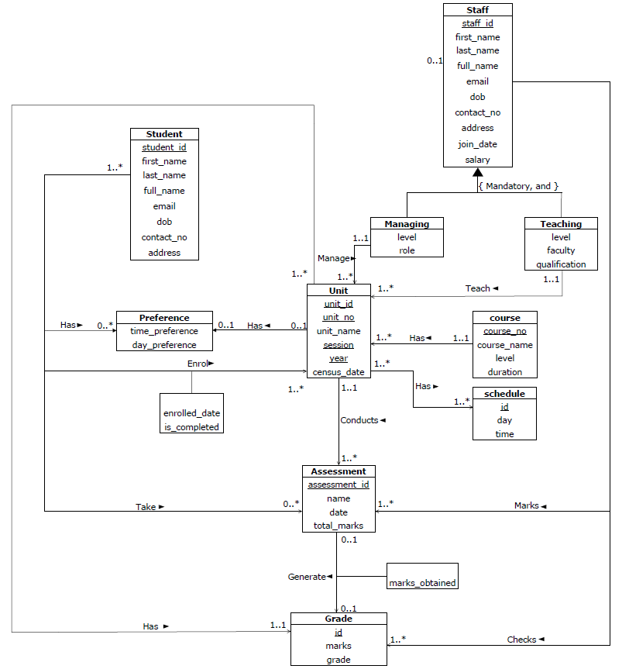

**SQL PRACTICES**

**TUTORIAL 1**

II. Connected into Microsoft SQL following the given instructions.

1) Follow the instruction, connect to the Web based MyLittle SQL Server.SQL – connect to the MyLittle SQL Server. 2. Change the password under “tools” “change password”.

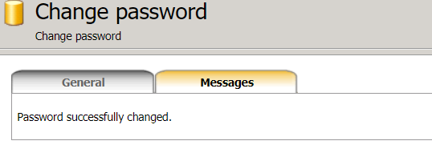

III. Table Creation and Deletion

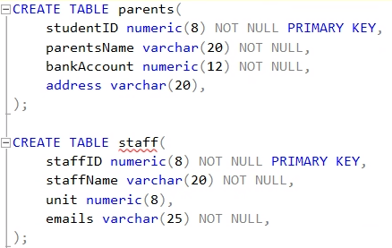

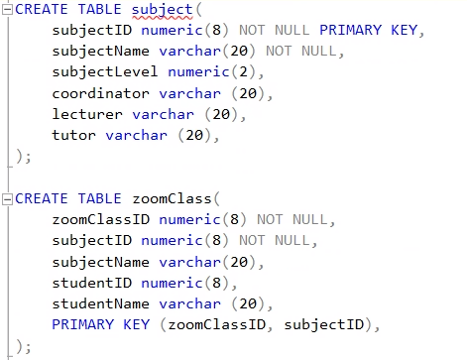

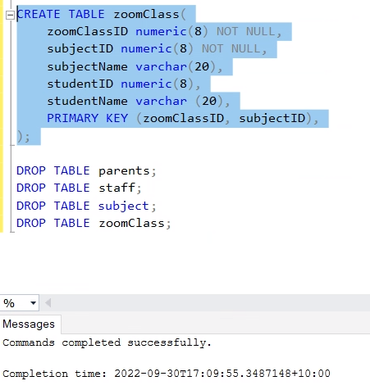

All the create table queries can be run successfully.

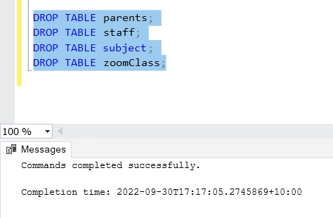

Recreate the tables by re-run the create table queries.

**TUTORIAL 3**

II. Insert, delete, update and select

1. Create a room table

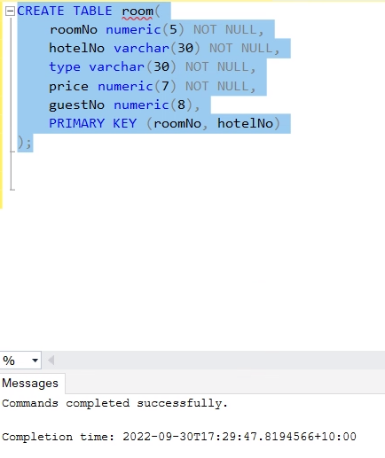

1. Insert some values into room table

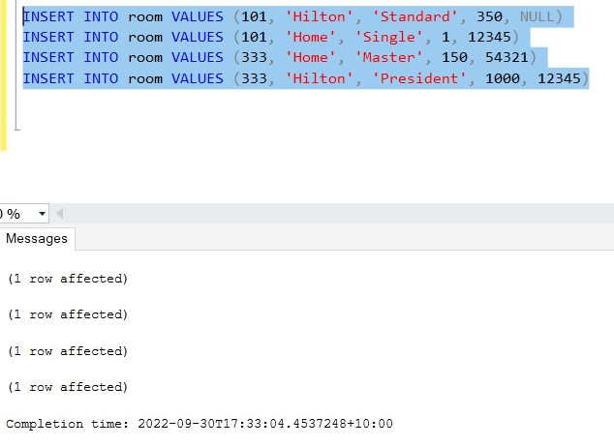

1. Result: Violation of PRIMARY KEY constraint, Cannot insert duplicate key.

It is because there is already a row having the same roomNo and hotelNo values.

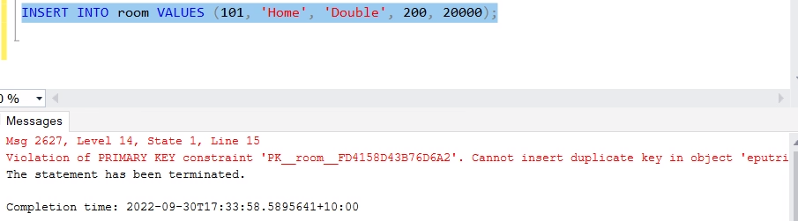

1. Cannot insert the value NULL into column 'hotelNo'.

It is because the property of hotelNo is a primary key, thus it can not be NULL.

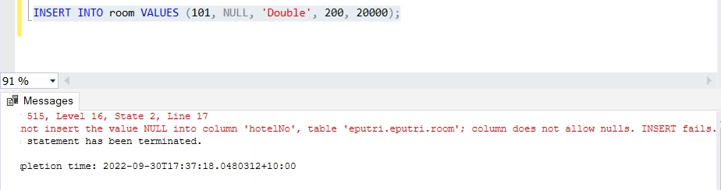

1. The query is successfully insert a new row.

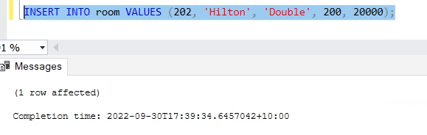

1. No row is affected since there is no room 303.

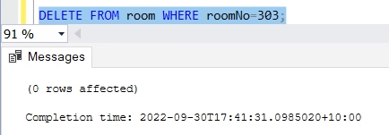

1. One row is affected by deleting room 333 and hotel number ‘Home’. Re-inserted is done.

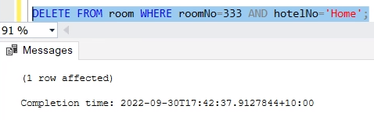

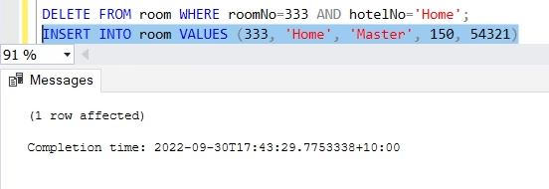

1. One row is affected by deleting room 333 and hotel number ‘Hilton. Re-inserted is done.

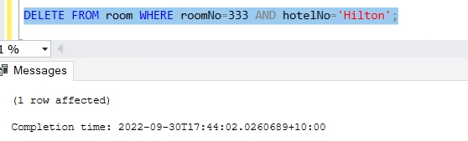

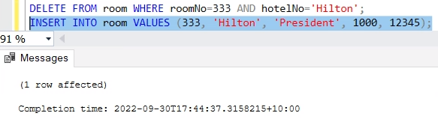

1. All records are deleted by truncate query (as attached) and then inserted back.

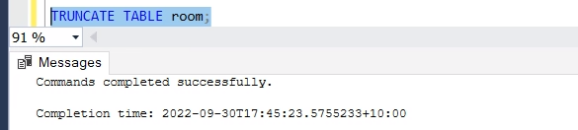 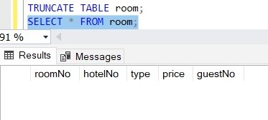 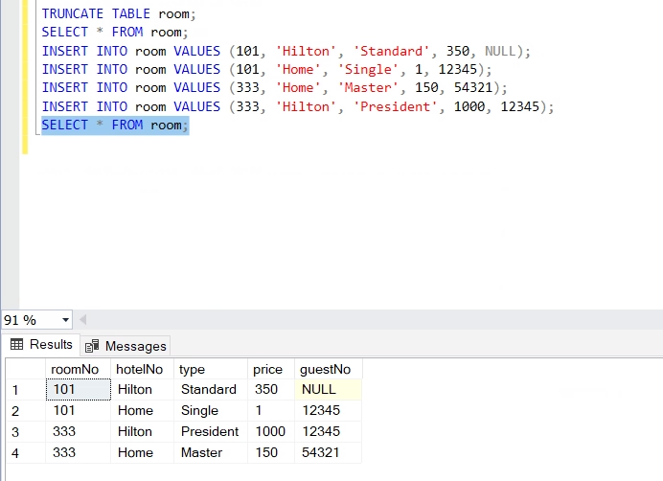

1. Room 333’s price in hotel Hilton is changed into 5500.

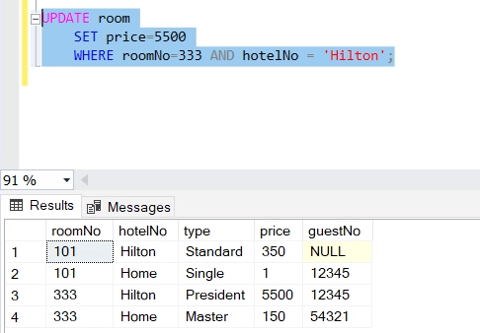

1. Price increasing for all room by 15%.

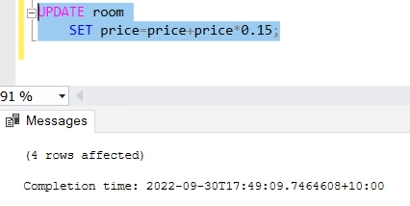

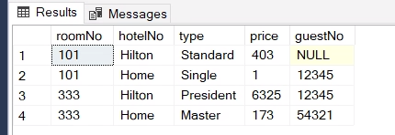

1. All rooms data in hotel Home.



1. RoomNo and room price in hotel Home.

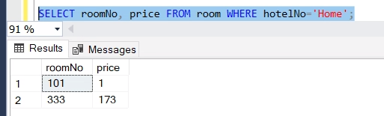

1. Insert into and update table.

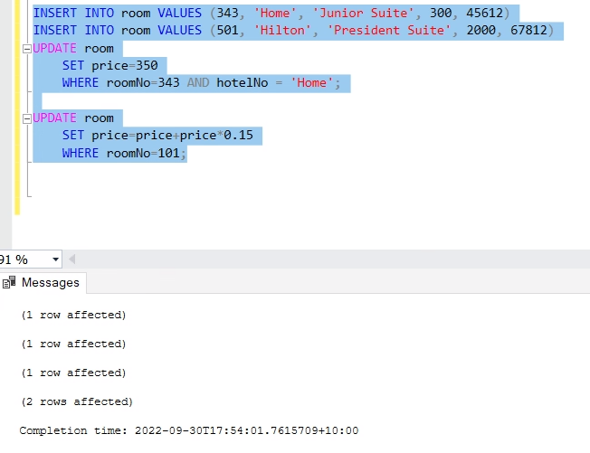 

**TUTORIAL 4**

Condition, Order by, Select, Alter

1. Room Table as Tutorial 3

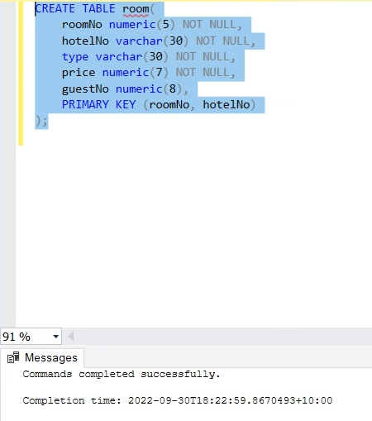

1. Distinct Value of hotelNo in room relation

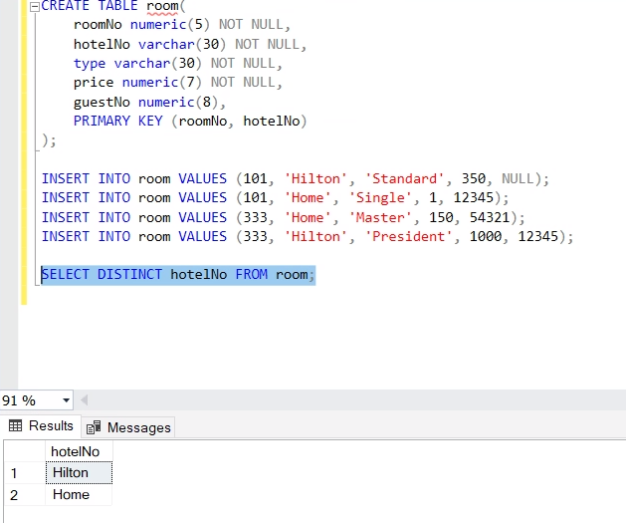

1. Room not in the hotel Home and number not 101

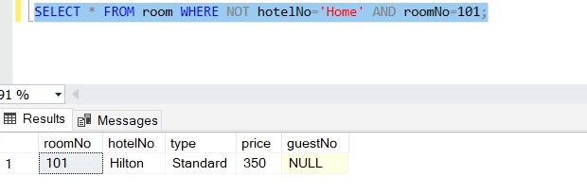

1. Room not in hotel Home or number not 101

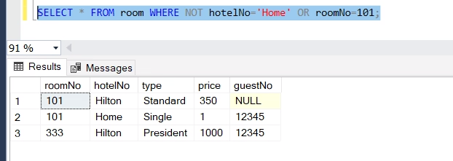

1. Room in hotel Home and order results in descendent order

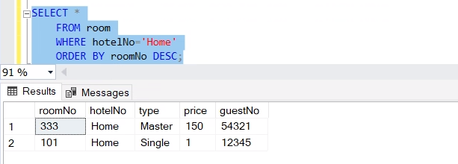

1. Room with price more than $110, order the results by price in ascendant order and type in descendent order.



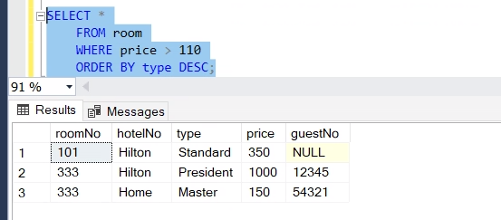

1. Add column view in room table, update view of roomNo 101 in hotel Home in oceanView

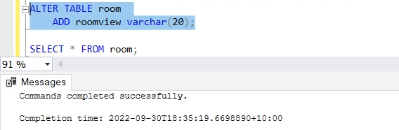

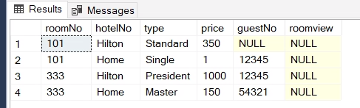

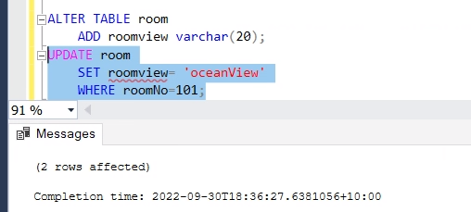

1. List all information in roomNo 101

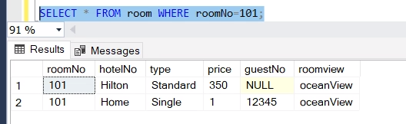

1. Drop field view

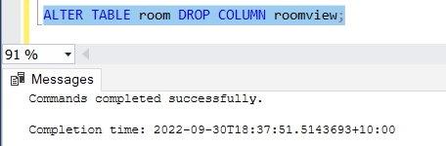

1. hotelNo can not be dropped because it is a primary key.

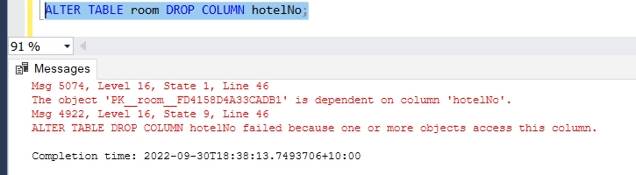

1. It is denied because of arithmetic overflow makes it error to convert from numeric into data type numeric in decimal.

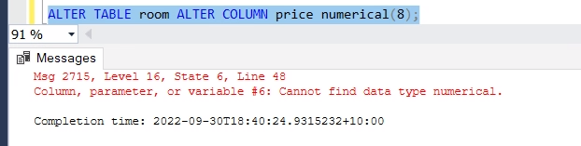

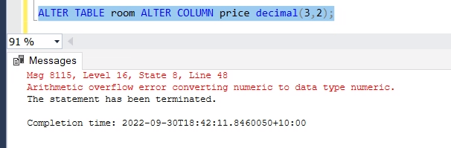

1. Relation guest without guestNo as primary key

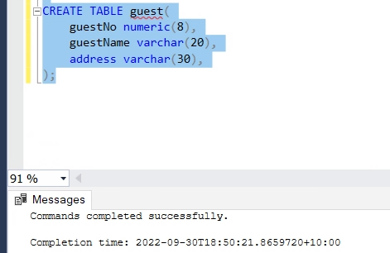

1. Drop column guestNo and re-add it.

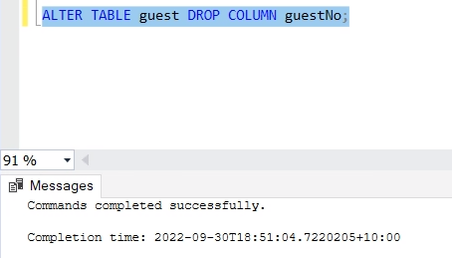

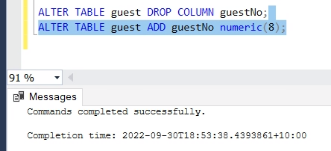 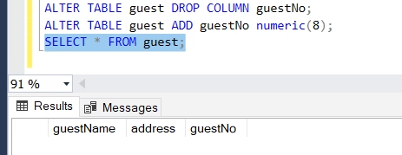

**TUTORIAL 5**

II. Constraints, aggregates, select

1. Drop all tables and recreate new room table

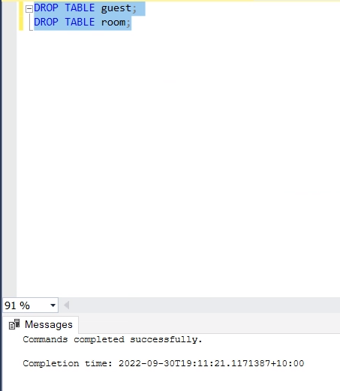

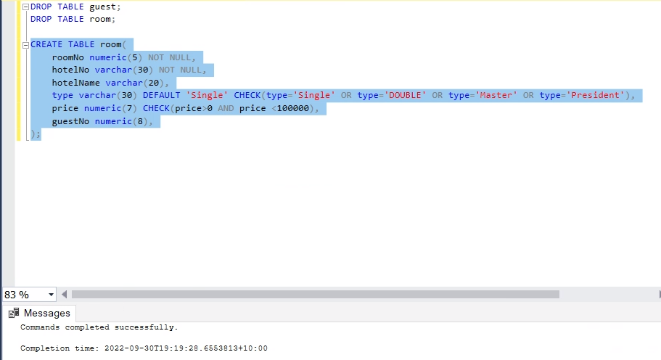

1. Alter table to create primary key

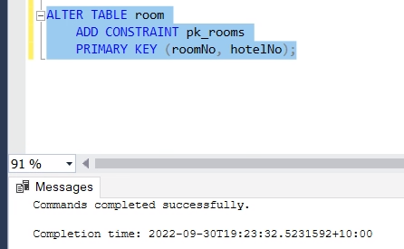

1. Assigning guestNo as foreign key is denied as the guest table has not created yet.

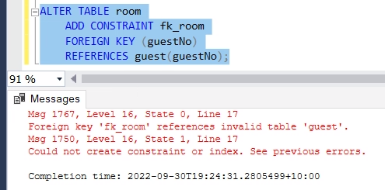

1. Create guest table.

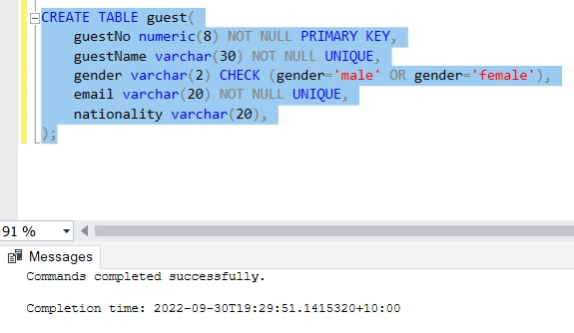

1. It is done successfully because guest table is created.

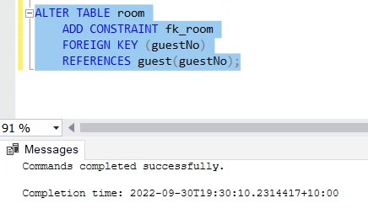

1. There is wrong order between gender and email. Also, the gender is already specified into male or female only. As a result, the data can not be inserted.

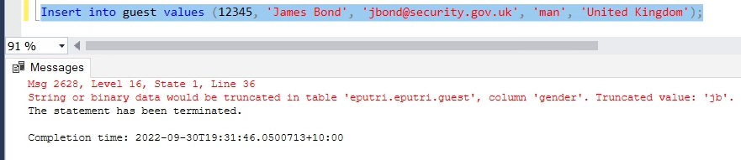

1. There is wrong order between gender, even the gender is well classified, and email. Thus, the data can not be inserted.

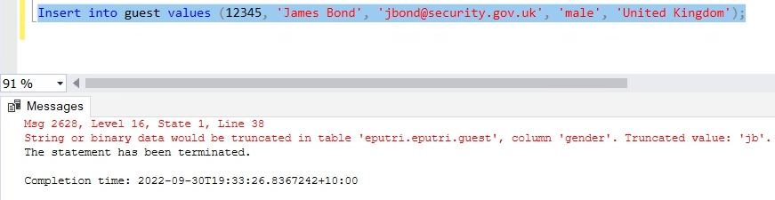

1. There is wrong order between gender and email, again. Also, the gender is already specified into male or female only. As a result, the data can not be inserted.

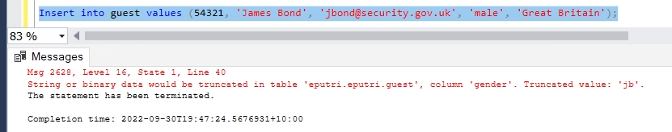

1. guestNo is the primary key of guest table which is can not be null.

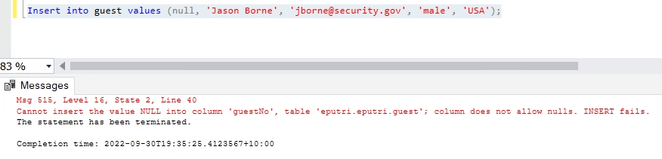

1. It is inserted to the guest table successfully. It does not violate the constraint because the gender is valued as null. The email, which is should be filled, does not have specified format, thus the ‘male’ is read as email address.

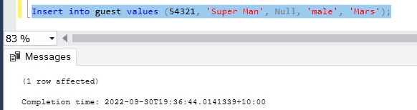

The second query is failed to be inserted because email column can not be null.

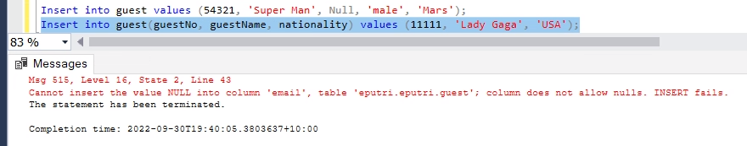

**TUTORIAL 6**

II. Select from multiple tables

1. Insert some records into room and guest tables

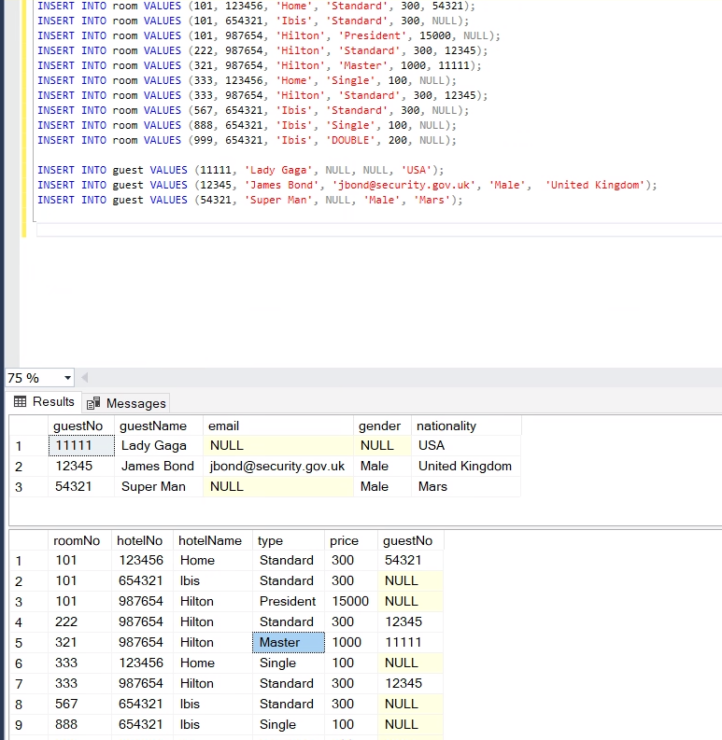

1. All rooms and guests when the guest has booked the room (where clause)

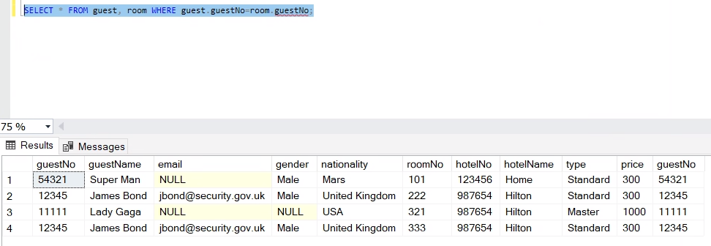

1. All rooms and guests when the guest has booked the room (join clause)

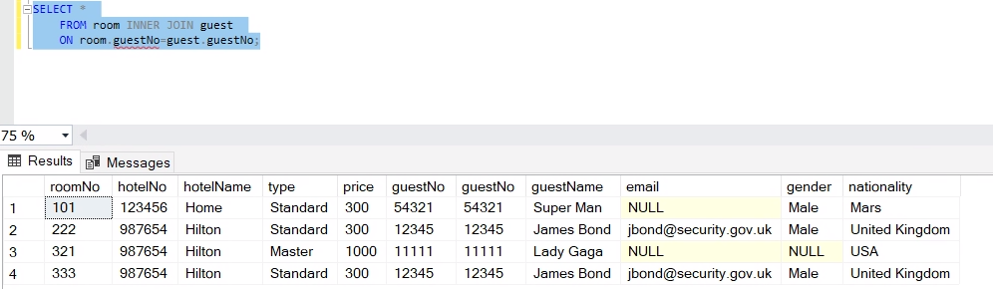

1. All rooms and guests when the guest has booked the room (variable)

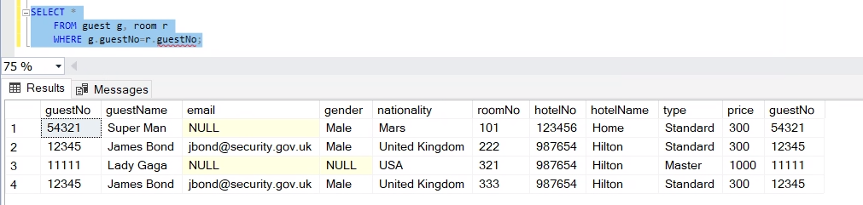

1. All room prices booked by James Bond (where clauses)

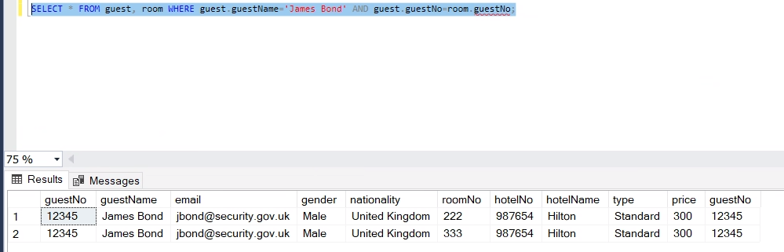

1. All room prices booked by James Bond (join clauses)

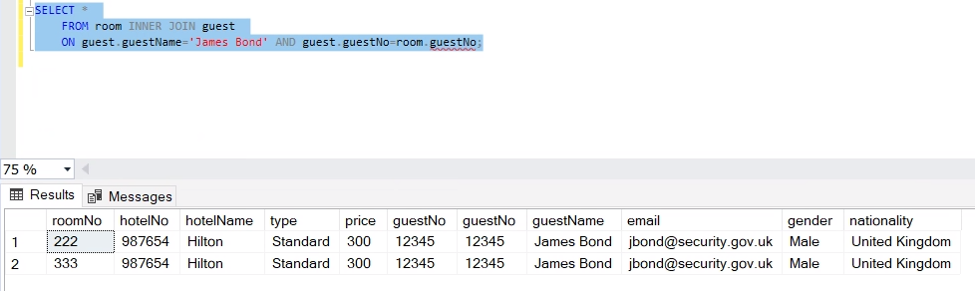

1. All room prices booked by James Bond (variables)

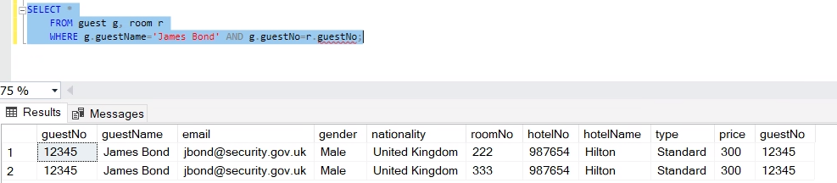

1. The query does not work because the guestNo appears in both room and guest table. It becomes an ambigous column where does it come from.

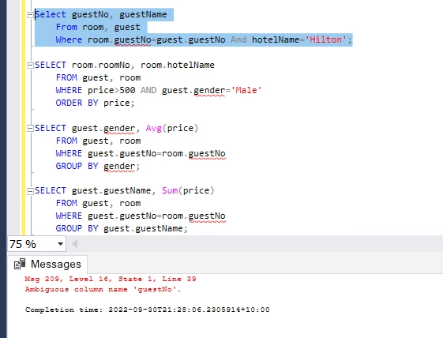

1. All room booked by male with price over 500, ordered by price, showing room number and hotel name.

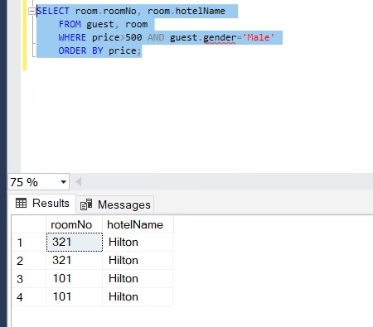

1. The gender is not mentioned in the other data, thus, it appears as NULL.

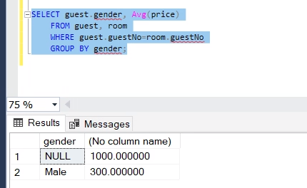

1. Overall price of rooms booked by same person

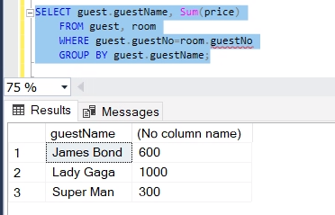

1. Number of rooms which has been booked by James Bond

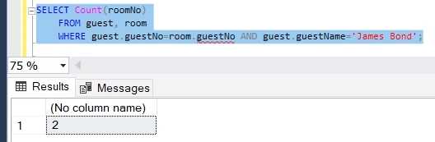

1. Guest who has bill more than 500

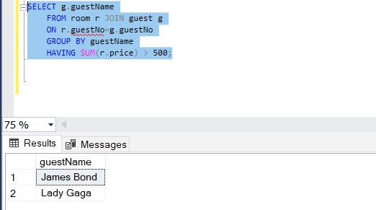

1. Guest who booked at least two rooms

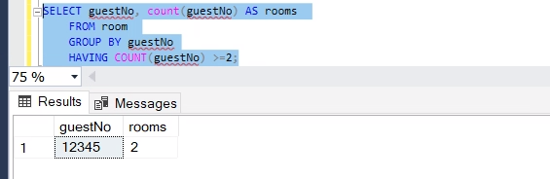

**TUTORIAL 7**

II. Outer join and nested query

1. Guest names and their room price

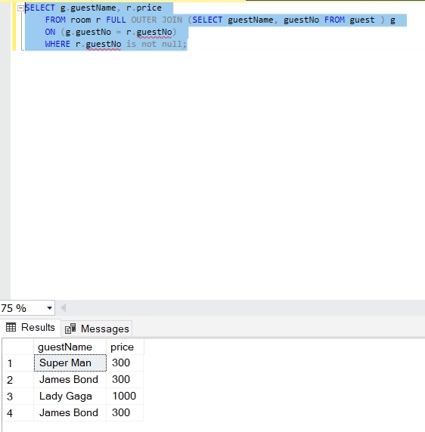

1. Guest names and overall room price

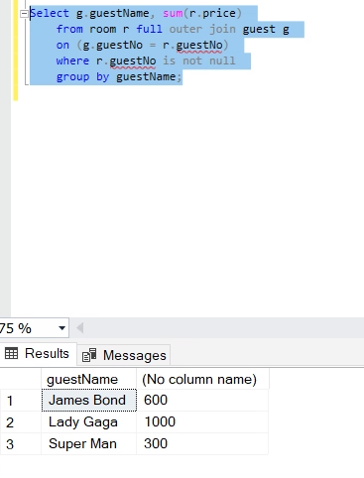

1. Create staff table

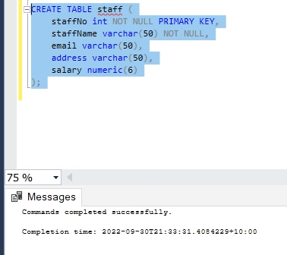

1. Insert some values into staff table

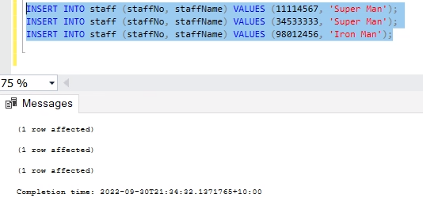

1. All staff names and guest names

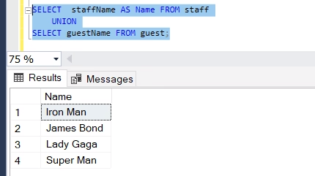

1. A staff who also guest using intersect keywords

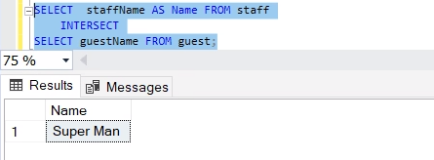

1. Staffs who are not guests

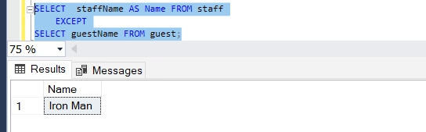

1. Selecting the rooms which have price more than half of the most expensive room in the room table

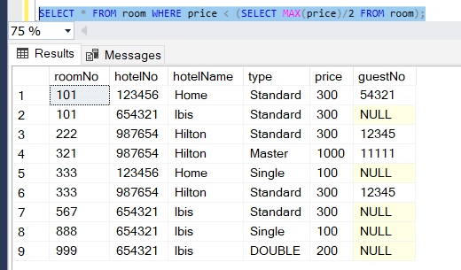

1. No guest has booked more than average price.

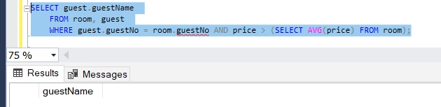

1. No guest has booked more than 3 rooms.

